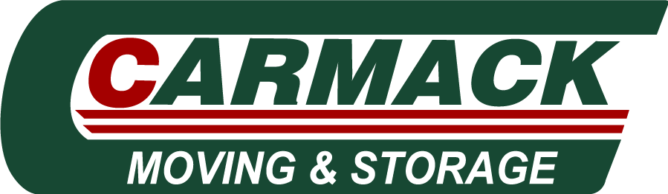

Residential Account Manager Job Description

Residential Account Manager

About Carmack Moving & Storage:
At Carmack Moving & Storage, we expertly move people and businesses around town and throughout the nation, and we have been providing moving services for over 35 Years. We are one of the best moving companies in Sterling VA and have a reputation for success and excellence. We pride ourselves on amazing customer service, accurate estimates and excel at providing expert moving services to clients in around Northern Virginia, Maryland and DC.
Job location: On the road and In the Office
Remote work allowed: No
Advertising location: Sterling, VA

Pay and Benefits: $50,000.00 - $80,000.00 per year
Benefits: Dental insurance, Health insurance, Paid time off, Paid training, Vision insurance
Supplemental Pay: Commission pay
- Benefit Conditions: Waiting period may apply, Only full-time employees eligible

Job Type: Full-time

Job Description: Sells Residential moving, storage, and other services to residential clients.
Responsibilities:
- Perform estimates to potential clients from advertising campaigns, mailing lists, telemarketing, and personal contacts.
- Solicits business from potential clients and promotes value of services.
- Interview clients to determine needs and resources and provides quotes to the client.
- Provides clients with information on services, rates and plans.
- Prepares various sales reports and performs calculations to monitor client accounts and verify transactions.
- Write up Work Orders for booked moves.
- Travel from home to home to perform multiple estimates a day.
Qualifications:
- 1-2 years of related sales or business development experience
- Ability to effectively present information and respond to questions from current or potential clients and decision makers.
- Ability to calculate work estimates, discounts, interest rates, proportions, percentages, area, circumference, and volume calculations.

COVID-19 precautions
- Social distancing guidelines in place

Expected questions to answer:
- What is the highest level of education you have completed?
- How many years of Sales Experience do you have?
- Please list 2-3 dates and time ranges that you could do an interview.
This Job Is: A job for which military experienced candidates are encouraged to apply, A good fit for applicants with gaps in their resume, or who have been out of the workforce for the past 6 months or more, A good job for someone just entering the workforce or returning to the workforce with limited experience and education, A job for which all ages, including older job seekers, are encouraged to apply, Open to applicants who do not have a college diploma.

- Company's website: www.carmackmoving.com
- Company's Facebook page: www.facebook.com/carmackmovingandstorage
- Schedule: Monday to Friday

