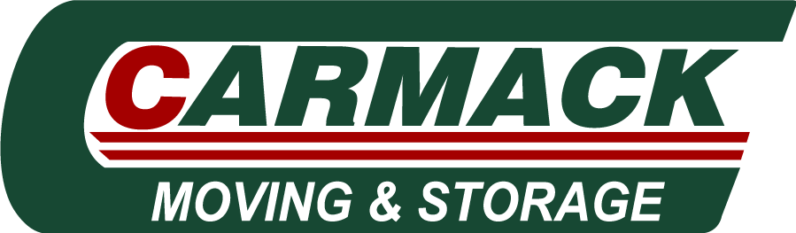
Mover & Helpers Job Description
About Carmack Moving & Storage:
At Carmack Moving & Storage, we expertly move people and businesses around town and throughout the nation, and we have been providing moving services for over 35 Years. We are one of the best moving companies in Sterling VA and have a reputation for success and excellence. We pride ourselves on amazing customer service, accurate estimates and excel at providing expert moving services to clients in around Northern Virginia, Maryland, and DC.
Reasons to join Carmack Moving & Storage:
Carmack Benefits:
- A relaxed and fun working environment

- Benefits like Health, Dental and Vision Insurance

- Paid Holidays
- Weekly Pay: You can expect a competitive wage and reliable weekly paycheck.
- Growth Opportunities: Many of our entry-level employees become leaders in move managers, Non-CDL drivers, operations, customer support, and other areas.
- Stay active: You'll be on the move for your whole shift in our fast-paced environments.
What we are looking for:
- Ability to function in a fast paced, sometimes high-pressured environment.
- Must be a self-starter, capable of operating with minimal direction or supervision.
- Candidates must have good communication skills and be able to lift up to 75 pounds on a routine basis.
- Must successfully pass a background investigation and pre-employment drug screening.
- Must be able to communicate clearly and concisely with other crew members, clients, and move coordinators.
- Reliable, punctual and available for flexible work schedules.
COVID-19 precautions

- Social distancing guidelines in place

Expected questions to answer:
- What is the highest level of education you have completed?
- How many years of Sales Experience do you have?
- Please list 2-3 dates and time ranges that you could do an interview.
This Job Is: A job for which military experienced candidates are encouraged to apply, A good fit for applicants with gaps in their resume, or who have been out of the workforce for the past 6 months or more, A good job for someone just entering the workforce or returning to the workforce with limited experience and education, A job for which all ages, including older job seekers, are encouraged to apply, Open to applicants who do not have a college diploma.

- Company's website: www.carmackmoving.com
- Company's Facebook page: www.facebook.com/carmackmovingandstorage
- Schedule: Monday to Friday

